* ***Important Note C++***
* ***C++ is not a fully object-oriented programming language.***
* ***C++ is traditionally an "unmanaged" language.***
* ***"Managed code" typically refers to code that is executed by a runtime environment, such as the Common Language Runtime (CLR).***
* ***It is a hybrid language that combines object-oriented and Linear programming techniques.***
* ***Overall, C++ is a powerful and versatile programming language. However, it is not a fully object-oriented programming language.***
* 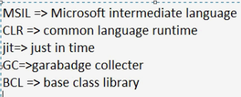A diagram of a computer hardware system

  Description automatically generated***Important Note C#.***
* ***C# Modern Programming language.***
* ***C# is Cross Platform.***
* ***C# Is Managed Code (GC).***
* ***C# Multipurpose Programing Language.***
* ***C# Is Fully object-oriented programming language.***
* ***C# is a statically typed language.***
  + *"That means that the data type of a variable must be declared before it can be use".*
* ***C# Is Strongly Typed.***
  + *"That meaning variables and objects must have a specific type declared at compile-time. "*
* ***C# includes Garbage Collection.***
  + *"That meaning automatic memory management through a garbage collector"*
* ***C# Is Platform Independence (Cross Platform.)***

